AC_Present
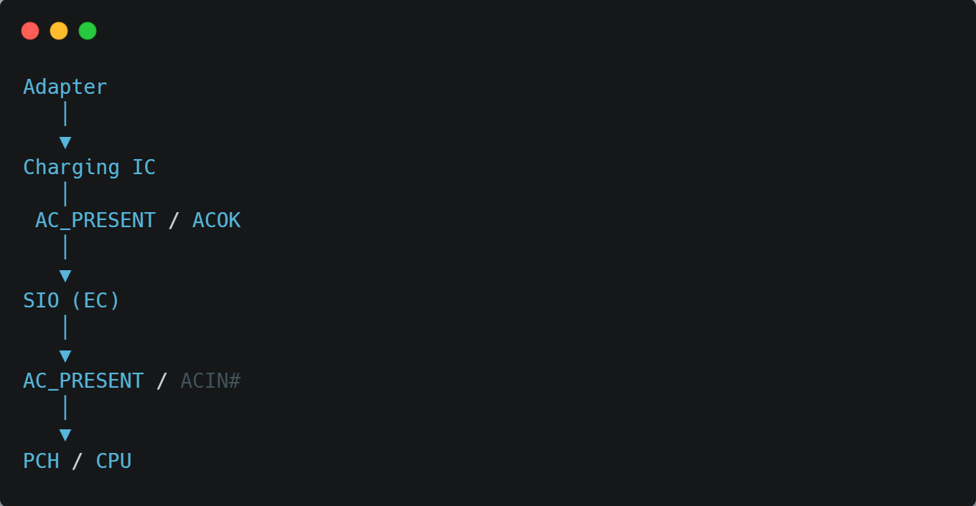
Signal | Direction
ACOK / AC_PRESENT | Charger IC → SIO
AC_PRESENT / ACIN# | SIO → PCH

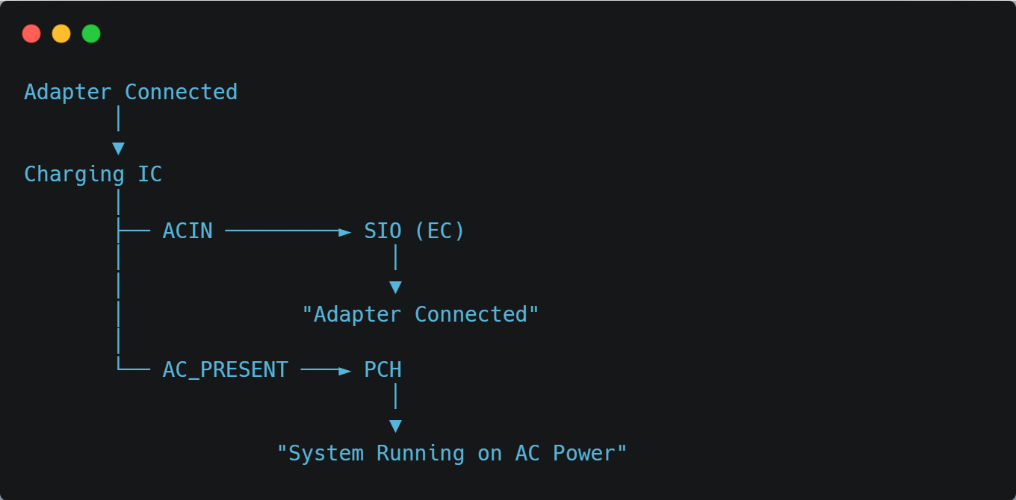
Signal | Kis ko jata hai | Kaam
ACIN | SIO (EC) | SIO ko batata hai ki Adapter connect hai.
AC_PRESENT | PCH (aksar SIO ke through ya direct) | PCH ko batata hai ki AC Power available hai.

Har motherboard me routing same nahi hoti:
- Kuch boards me Charging IC → SIO → PCH hota hai.
- Kuch boards me Charging IC → PCH direct bhi hota hai.
- Kuch boards me signal ka naam ACOK, AC_PRESENT, ACIN, ACDET ya ADP_PRESENT bhi ho sakta hai.

ACIN and AC_PRESENT
1. ACIN
ACIN sirf tab active hota hai jab Adapter connected ho.
Adapter ✔️ → ACIN = HIGH
Battery ❌ → ACIN = LOW
Reason:
ACIN ka matlab hi hai "AC Adapter Input Detect".

2. AC_PRESENT
Ye board design par depend karta hai.
Case 1 (Most Common)
Adapter ✔️ → AC_PRESENT = HIGH
Battery Only ❌ → AC_PRESENT = LOW
PCH ko pata chal jata hai ki system adapter par chal raha hai.

Case 2 (Kuch Modern Boards)
Battery par bhi PCH boot kar sakta hai.
Us case me PCH ko battery ki information alag signal se milti hai.
Jaise:
- BAT_PRESENT
- BATLOW#
- SMBus (SCL/SDA)
- Battery Fuel Gauge IC
Isliye AC_PRESENT LOW hone ke baad bhi laptop battery se ON ho jata hai.
Ek Important Point
Laptop battery par bhi normally ON ho jata hai, kyunki PCH ko sirf AC_PRESENT par depend nahi rehna padta. Battery ki information Battery Charging IC aur SMBus (SCL/SDA) ke through bhi milti hai.
Repair ke liye yaad rakhiye:
- ACIN = "Adapter detect."
- AC_PRESENT = "System AC mode me hai."
- Battery mode me AC_PRESENT zaroori nahi HIGH ho. PCH battery ki information dusre signals se bhi le sakta hai.

